Comparing bacterial community composition of Montastraea cavernosa mucus between exposure to high and low levels of freshwater discharge from the St. Lucie Canal

Abstract

The welfare of coral reefs has been greatly threatened by climate change and human-related activity, such as pollution, dredging, and overfishing. In the St. Lucie Reef, coral are exposed to high levels terrestrial and freshwater discharge from several surrounding sources, including Canal C-44, which channels water from Lake Okeechobee. Several stressors negatively impacting coral physiology are introduced by the discharge water, such as elevated nutrient levels and increased turbidity. Microbial communities associated with coral are greatly affected by environmental conditions and play a large role in coral health. This study investigated the effects of discharge water on the microbial community composition on the surface of the reef-building coral, Montastraea cavernosa. Using LH-PCR to characterize the communities, a significant shift in composition was observed between the communities of colonies exposed to a low level of discharge water from Canal C-44 versus exposure to a high level of discharge water. Evidence for contamination by discharge-associated microbes includes the observed lower abundance of heterotrophic bacteria and higher abundance of sulfide-oxidizers in the communities of the high discharge level group versus those of the low discharge level group. Additional sequencing and analysis could determine how the shift specifically impacts M. cavernosa health.

Introduction
Anthropogenic effects and climate change have taken a significant toll on the livelihood of the extraordinarily diverse and economically significant coral reefs (Burke et al 2004). Within the past forty years, reef-building coral cover has reduced by approximately 80% in the Caribbean basin (Gardner et al 2003). One source of damage to reefs includes terrestrial inputs, such as nutrient-saturated stormwater runoff and sewage waste (Wear and Thurber 2015). Water from these sources can significantly alter seawater surrounding reefs several ways, such as changing salinity, turbidity, and nutrient levels. These altered conditions often negatively impact coral physiology, including: stifling coral feeding, promoting algal dominance, and increasing coral susceptibility to disease and bleaching (Fabricius 2005, Pollock et al 2014).
During Florida’s rainy, or wet, season, coral in the St. Lucie Reef are subject to freshwater discharge up to ~6000 cubic feet per second (cfs) from St. Lucie Estuary through the St. Lucie Inlet. Approximately one third of this freshwater ultimately derives from Lake Okeechobee (Beal et al 2012). During flooding events or periods of heavy rainfall, excess water from Lake Okeechobee is channeled through Canal C-44, which accumulates pollutants that eventually empty into the St. Lucie Inlet. Additional sources of agricultural and terrestrial pollutants in the St. Lucie Inlet include the St. Lucie River and drainage canals C-23 and C-24 (Sime 2005).
The St. Lucie Reef is considered the northernmost limit for several reef coral species. Considering its exposure to various sources of terrestrial water discharge and its location’s unique biological significance, protective efforts have been established by organizations such as the Southeast Florida Coral Reef Initiative to monitor and maintain this reef (Beal et al 2012). Specifically, the boulder star coral species, Montastraea cavernosa, has been monitored over the past five years.
The characteristics of M. cavernosa make it an ideal candidate for studying the impact of discharge water-associated stressors on coral. M. cavernosa colonies have been observed in along both east and west edges of the Atlantic Ocean, from Bermuda to West Africa. With habitable depths ranging from 3m to 100m, M. cavernosa has been regarded as an extreme depth generalist (Serrano et al 2014). This species existence in such a variety of habitats could explain its tolerance to the stressors present in the St. Lucie Reef.
To understand the physiology of this species’s tolerance to discharge water-associated stressors, one must consider the coral holobiont. The coral holobiont includes the coral’s animal tissue, symbiotic algae, and associated microbial communities, such as mucus bacteria. These symbiotic relationships are necessary to sustain coral health (Tracy et al 2015). A variety of microbial species reside in the layer of mucus coral secrete on their surface, comprising the surface mucopolysaccharide layer (SML) (Ritchie and Smith 2004); some of which have been found to aid the host coral in cycling nutrients and/or producing antibiotic compounds against coral pathogens (Lesser et al 2007; Ritchie 2006). In particular, Olson and Lesser (2013) have analyzed the diversity of nitrogen-fixing bacteria in the SML community of M. cavernosa. Other studies have detected dissolved inorganic phosphate consumption by bacteria in the SML community of Acropora spp. (Nakajima et al 2014). Roughly 25% of culturable bacterial strains in the SML communities of stony corals have shown bioactivity against bacterial species E. coli and B. cereus, which have been implicated as threats to coral health (Shnit-Orland and Kushmaro 2009). Due to the nutrient cycling and defensive roles of SML communities, the composition of this community can suggest the state of a coral colony’s health.
As proposed in the Coral Probiotic Hypothesis, environmental conditions influence the assemblage of associating microbes, through selection of those that most benefit the host coral. This relationship between the environment and microbial community means that microbial community species composition can differ across coral host species, time, and location (Reshef et al 2006). Recent studies have corroborated this hypothesis. From Spring to Fall, the microbiome of the mounding coral Orbicella faveolata has been found to significantly shift between seasons (Kimes et al 2013). In the South China Sea, the microbiota of the Galaxea astreata colonies from two different sites contrasted each other considerably. During the 2010 thermal anomaly in the Caribbean, microbial communities residing in the sea fan coral Gorgonia ventalina decreased in diversity throughout the bleaching event (Tracy et al 2015).
Considering the potential impacts environmental conditions can have on coral microbial communities and the critical role of SML microbial communities in coral health, this study aimed to identify the influence of discharge water on the SML microbial communities of M. cavernosa colonies in the St. Lucie Reef at three sites. Considering that microbes from the coral’s oral epidermis may have been introduced during sampling, the community analyzed in this study will be referred to as the surface community. The surface communities were compared between a time of low of level of discharge water, and high level of discharge water.
These communities were characterized using length heterogeneity polymerase chain reaction (LH-PCR) to detect the presence and abundances of different species and/or groups of species of microbes. Previous studies have shown LH-PCR is an accurate, useful method for comparing bacterial community compositions of coral mucus (Sekar et al 2006). LH-PCR uses universal primers to amplify hypervariable region V1 and V2 of the 16S ribosomal DNA in bacteria. The length, or number of base pairs, of this amplified region is specific to different taxons (Voss et al 2007). This study will analyze the amplicon lengths to determine the composition of surface communities. By understanding the degree of impact discharge water has on the surface microbial communities of M . cavernosa colonies, the health of M. cavernosa can be assessed for protective and restorative measures, such as possibly providing evidence for the need of stormwater treatment plants.

Methods

Sample collection. Discharge from the canal C-44 is the primary source of the fluctuations in discharge water in the St. Lucie Reef. Thus, flow rate of water in the C-44 canal was used to determine the time points of sample collection. M. cavernosa mucus samples used in this study were collected from the St. Lucie reef at two time points. Samples collected on August 8, 2013 represent the coral surface community composition during high levels of freshwater discharge (5671 cfs, n=13). Those collected on June 12 2014, represent the composition during low levels of freshwater discharge (0 cfs, n=12) (Figure 1). Multiple colonies were sampled from three sites within the St. Lucie Reef, Central, Ledge, and South, at each discharge level (Figure 2, Table 1. Table 2). Mucus was taken from the coral colonies with syringes and stored with seawater in 15mL tubes at -20°C.
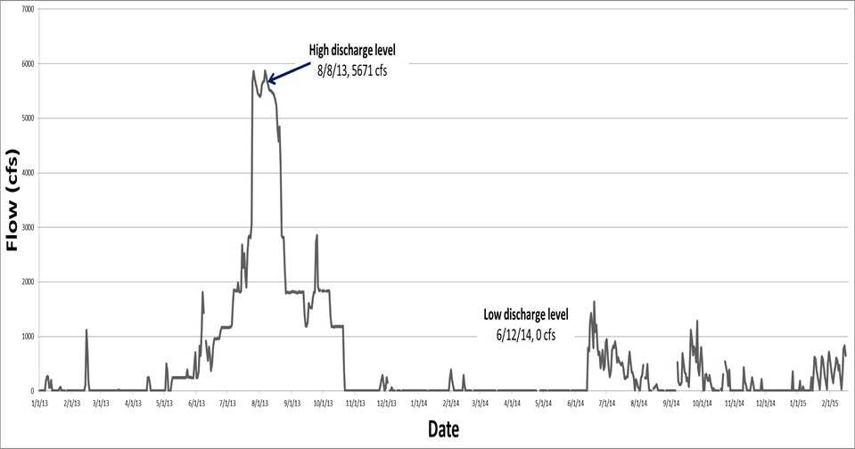
Figure 1 Discharge flow level from 1/13 to 2/15, cfs = cubic feet per second

Figure 2. Map of St. Lucie Reef sampling locations: Central, Ledge, South (ArcGIS).

Table 1. Number of M. cavernosa colonies sampled at each discharge level and location.
 | Central | South | Ledge | Total
Low Discharge Level | 4 | 4 | 4 | 12
High Discharge Level | 3 | 4 | 6 | 13
Total | 7 | 8 | 10 | 25
Low Discharge Level = low level of discharge water in June 2013
High Discharge Level = high level of discharge water in August 2014

Table 2. Colony identification label with corresponding discharge level exposure and location.
Colony ID | Discharge Level | Location
SC1 | Low | Ledge
SC3 | Low | South
SC4 | Low | Central
SC5 | Low | Ledge
SC6 | Low | South
SC7 | Low | Central
SC8 | Low | Central
SC9 | Low | Central
SC10 | Low | Ledge
SC11 | Low | Ledge
SC12 | Low | South
SC13 | Low | South
SC14 | High | Central
SC15 | High | Ledge
SC16 | High | Ledge
SC17 | High | Ledge
SC18 | High | Ledge
SC19 | High | Ledge
SC20 | High | Ledge
SC21 | High | Central
SC22 | High | Central
SC23 | High | South
SC24 | High | South
SC25 | High | South
SC26 | High | South
SC = surface community

Bacterial DNA extraction from mucus. DNA was extracted from the M. cavernosa mucus samples using the MoBio Biofilm Extraction Kit, MO BIO Laboratories, Inc., Carlsbad, CA, with slight modifications. These modifications included pelleting the mucus prior the first step. Concentrations of DNA were measured using the Nanodrop2000 and subsequently diluted with molecular grade water to a standard 10ng/uL. The DNA was then stored at -20°C until further use.

16S rRNA regions amplification. 16S rRNA genes at the hypervariable regions V1 plus V2 in the genome of each colony’s mucus were amplified for LH-PCR using the fluorescently labeled primer 27F (5′-[6FAM] AGAGTTTGATCCTGGCTCA G-3′) and unlabeled reverse primer 355R′ (5′-GCTGCCTCCCGTAGGAGT-3′). Each reaction contained 7.8µL DEPC water, 2µL 10X Reaction Buffer, 2µL of 25mM MgCl2 Buffer, 2µL of deoxynucleoside triphosphate containing 0.25mM of each, 0.5µL of each primer, 0.2µL of Amphigold Taq Polymerase, 2µL of bovine serum albumin, and 10 ng of DNA, for a total volume of 20µL. The reactions were run using an Eppendorf Thermocycler. The program for the reactions began with a denaturing period of 11 minutes at 94°C. Next, 30 cycles proceeded with a denaturing step of one minute at 94°C, annealing step of one minute at 55°C, and extending step of one minute at 72°C. A final extension step then held the cycler at 72°C for 10 minutes. The PCR products were subsequently stored at 4°C until further use.
PCR products were run on a 1% TBE agarose gel with a 6X TriTrack DNA ladder (Thermo Scientific, Waltham, MA) to ensure the targeted sequences were amplified adequately. The PCR products were delivered to the Forensic DNA Profiling Facility at Florida International University, Miami, FL for analysis. A capillary electrophoresis was run to separate the amplicons by base pair length. The master mix for each sample in the electrophoresis contained 11.5ul HiDi Formamide + 0.65ul Genescan 600 LIZ dye size standard. 1 ul of PCR product was added to 12ul of master mix. With an injection voltage and time of 1.2kV and 23 seconds, the capillary electrophoresis was run on the 3130xl Genetic Analyzer using POP-7, Module DS 33, filter G5 and GeneScan LIZ 600 internal size standard (Life Technologies) with a voltage of 15kV at 60 deg C. The electropherograms were processed through GeneMapper, with an amplicon analysis range of 300-380bp in length, a bin width of 1bp, and a minimum intensity threshold set at a peak height of 50.

Data processing. The data was received in an Excel file containing sizes of fragments and their corresponding intensities, peak heights, for each colony’s surface microbial community. The different sizes indicate the presence of different species or groups of species in the bacterial community, and the heights of the sizes denote the abundance of those species or group of species. Relative abundances of the sizes were used as a reflection of the composition of a colony’s surface microbial community. Community profiles were visualized in bar graphs containing the lengths along the horizontal axis and corresponding relative abundance along the vertical axis (Figure 2).

Surface microbial community composition comparison. A Bray-Curtis similarity distance matrix was designed on the standardized by total, root-transformed relative abundances. The differences in communities of colonies calculated in the Bray-Curtis similarity matrix were visualized with planar and three-dimensional multidimensional scaled (MDS) plots (Figure 3 and Figure 4).
Because both discharge level and location can impact a coral’s surface community, a two-way crossed ANOSIM was ran in PRIMER 6 to identify statistically significant differences in community composition due to both factors (R max=1, p=0.05) The two-way ANOSIM was performed on the square-root transformed distance matrix. Similarity percentage (SIMPER) was used to determine how much each amplicon differed in abundance between the discharge groups. Additionally, one-way ANOSIMs were run at each discharge level to identify whether or not location was a significant factor only at a single discharge level or both.

Results

Influence of discharge level on surface community composition. LH-PCR profiles of the microbial communities on the surface of the coral colonies were received for 25 colonies. Ranging from in length from 302 base pairs (bp) to 372 bp, a total of 33 distinct amplicon lengths were detected within the communities. The SML communities of coral exposed to low levels of discharge water contained amplicon lengths which ranged from 302 bp to 372 bp, and those exposed to high levels of discharge water contained lengths ranging from 302 bp to 368 bp. Figure 2 displays the average relative abundances of each amplicon length in the SML communities exposed to low levels of discharge water and high levels of discharge water.

Figure 3 SML microbial community profiles of the average profile of coral colonies exposed to the low level of discharge water and high level of discharge water.
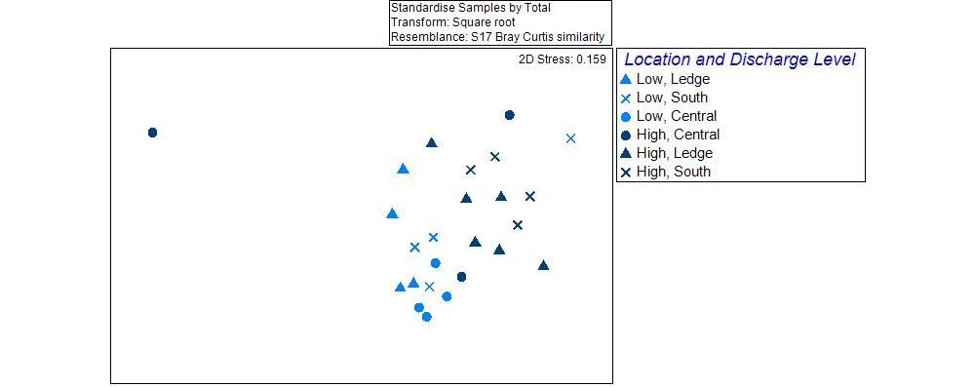
In both the planar MDS plots of the surface communities, the communities of colonies exposed to the low level of discharge water are clustered separately from those exposed to the high level of discharge water (Figure 4). Positioned relatively distant from the other community composition points in the MDS plot, the composition of SC21 is very distinct from all of the other communities, possibly a result of contamination in the sample. The point representing the composition of SM13 greatly deviates in position compared to the other low discharge level points in the MDS plots.
Figure 4 Planar MDS plot from the standardized by total, square-root transformed Bray-Curtis similarity matrix of the SML microbial communities. Each point represents a single SML community’s composition. Its position is based on its similarity to the composition
Low = low discharge level
High = high discharge level

Statistical analysis of the influence of discharge level on SML community composition in a two-way crossed ANOSIM (with replicates) corroborated the MDS plot distinction of the communities. The SML communities exposed to the low level of discharge water were significantly different from those exposed to the high level of discharge water (p=0.001, R=0.549). The location test result of this ANOSIM was significant (p=0.01, R=0.213), the low R value prevents interpretation of this result.
The SML communities of the two discharge groups differed in the presence and abundance of 20 species or groups of species, represented by amplicon lengths. Each amplicon length contributed to roughly 10% or less of the differences between the groups. Roughly 50% of the differences between the discharge groups is derived from the contribution of 7 amplicon lengths. At 10.19%, the relative abundance of amplicon length 345 contributes the most to the dissimilarity between the two groups, followed by 313 at 9.87%, and 310 at 7.84%.

Table 3. SIMPER output of dissimilarity between amplicon abundances in the discharge groups
Amplicon length (bp) | LD mean rel. abund. | HD mean rel. abund. | Contrib% | Cum.%
345 | 12.18 | 0.65 | 10.19 | 10.19
313 | 24.38 | 24.75 | 9.87 | 20.06
310 | 14.55 | 16.51 | 7.84 | 27.9
341 | 3.39 | 4.31 | 6.47 | 34.37
343 | 5.72 | 4.79 | 5.67 | 40.05
342 | 3.7 | 1.7 | 5.27 | 45.32
309 | 2.66 | 5.63 | 5.03 | 50.34
312 | 2.81 | 4.93 | 4.88 | 55.23
344 | 1.69 | 4.57 | 4.56 | 59.79
350 | 2.49 | 4.97 | 4.51 | 64.3
358 | 1.11 | 2.53 | 3.35 | 67.65
324 | 1.33 | 4.29 | 3.35 | 70.99
357 | 0.3 | 3.57 | 3.33 | 74.33
355 | 0.54 | 2.25 | 2.74 | 77.07
335 | 5.24 | 2.92 | 2.57 | 79.64
338 | 3.04 | 0.71 | 2.52 | 82.16
354 | 2.73 | 0.1 | 2.27 | 84.43
336 | 2.43 | 0.66 | 2.21 | 86.64
339 | 2.23 | 1.64 | 1.88 | 88.52
322 | 1.26 | 2.63 | 1.78 | 90.29
Av. Abund. = average abundance, Av. Diss. = average dissimilarity, Diss/SD = dissimilarity standard deviation, Contrib % = percent contribution, Cum. %, cumulative percent

Influence of location on SML community composition. For each discharge level, MDS plots were created on the square-root transformed, Bray-Curtis similarity matrices. The position of the points representing SML communities exposed to low discharge water did not cluster by location. In the planar MDS plot, the points from each location are relatively evenly distributed (Figure 4A). The output of a one-way ANOSIM indicates location does not significantly influence the composition of SML communities in coral colonies exposed to low discharge water (p=0.304, R=0.032). Similarly, the composition of communities from coral colonies exposed to high levels of discharge water does not appear to substantially differ between locations. Aside from colony 21, the composition of the SML communities from all of the other colonies appear intermixed in both MDS plots (Figure 4C). The p-value of ANOSIM output suggests that the compositions are significantly different between locations, but the relatively low R value, along with the point distribution on the MDS plots, does not invite strong interpretation of this result (p=0.016, R=0.316).
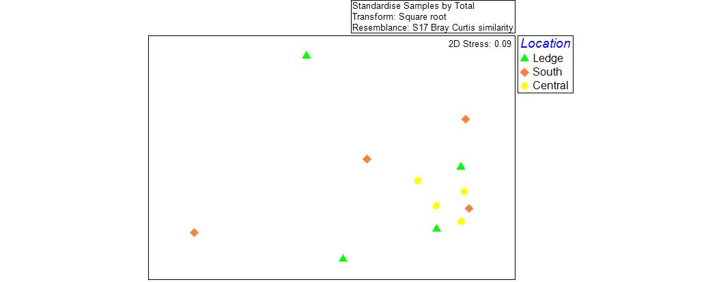

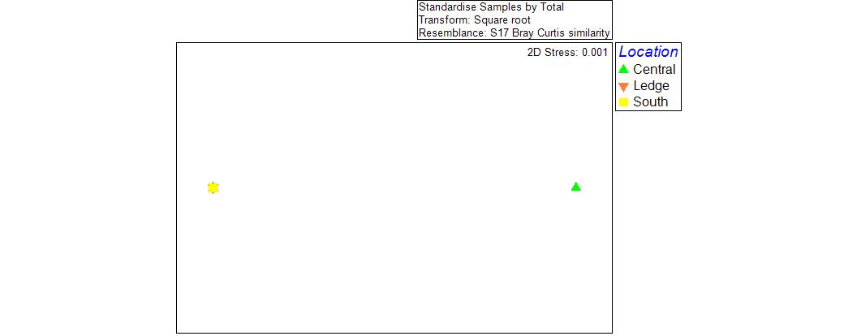
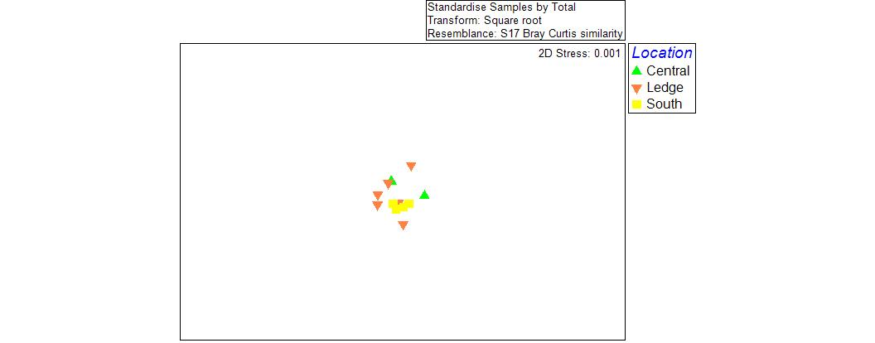
Figure 5 Planar MDS plots of the standardized by total, square-root transformed Bray-Curtis similarity matrix of the communities exposed to the low level of discharge water (A), high level of discharge water (B). The high discharge level plot was zoomed in on the majority of the colonies to clarify the point distribution (C). Each point represents a single SML community’s composition. Its position is based on its similarity to the composition of other SML communities. The color and shape of each point represent the community’s location.

Discussion

The results of this study show the composition of the microbial communities on the surface of Montastraea cavernosa colonies shifted between time periods of varying discharge levels. Approximately two thirds of the species or groups of species, represented by amplicon lengths in the LH-PCR profiles, differed at relatively low percentages between the communities. This shift in the abundance of several taxons at low levels suggests that the surface community of M. cavernosa is relatively stable, but can be slightly altered when environmental conditions change substantially, such as the influx of high levels of freshwater discharge water.
Heterotrophs, corresponding to amplicon lengths 335 to 345, were less abundant in the high discharge group than the low discharge group. In particular, heterotrophs corresponding to length 345 were present at 12% in the low discharge group but nearly absent in the high discharge group at 0.65%. Heterotrophic communities tend to thrive in oligotrophic conditions (Duarte et al 2013). The introduction of eutrophic water during high flow of discharge water could explain the decrease in heterotrophs observed in the surface communities of the high discharge level group (Lapointe et al 2012).
Further evidence for discharge water contamination on coral surface communities is the relative abundance of amplicon length 357. Amplicon length 357 likely corresponds to sulfide oxidizers and other microbes associated with anoxic environments (Joshua Voss, personal communication, June 21, 2015). The average relative abundance of amplicon length 357 was roughly 12 times higher in the surface communities of the high discharge group (3.57%) than those of the low discharge group (0.3%).
Taxons corresponding to length 313 shared a similar average relative abundance between the discharge groups, roughly 24%; however the dissimilarity value of these relative abundances was relatively high at 5.03. A likely reason for the high value is that the relative abundance of 313 varied greatly in one of the discharge groups, but was relatively consistent in the other discharge group. The amplicon length 313 is associated with alphaproteobacteria and cyanobacteria (Joshua Voss, personal communication, June 21, 2015). Cyanobacterial blooms have been documented in Lake Okeechobee (Lapointe et al 2012). The results of this do not indicate an increase specifically in cyanobacteria in the surface communities of the high discharge group; however, the high dissimilarity between the two discharge groups suggest a possible shift in the distribution of cyanobacteria or other related microbes among the communities, which could have been a result of freshwater discharge.
Overall, while this community shift may implicate freshwater discharge contamination in altering the surface community composition of M. cavernosa, the alteration may not directly impact the host coral’s physiology. This study’s results showed species or groups of species in the surface communities varied at relatively low percentages between the discharge levels. The seemingly slight alteration has potential to be quite momentous. In a study by Ainsworth et al, ubiquitous and physiologically essential microbes of the core coral microbiome were found to be present at abundances less than 1% across all species analyzed (2015). However, because LH-PCR can only identify community members at the phyla level, additional sequencing and analysis is required to reveal whether the abundance of biologically critical microbes was impacted.
Stormwater treatment plants are currently under construction to minimize the destructive effects of discharge water from Lake Okeechobee. The threat of harmful microbes from freshwater discharge may be reduced by these efforts. However, understanding the current state of M. cavernosa surface communities at present can help shape additional protective and restorative measures of this species.

References

Ainsworth, T. D., Krause, L., Bridge, T., Torda, G., Raina, J. B., Zakrzewski, M., ... & Leggat, W. (2015). The
coral core microbiome identifies rare bacterial taxa as ubiquitous endosymbionts. The ISME
Journal.
Beal, J., Voss, J., Edge, S., & Cohen, L. (2012). Assessment of Coral Stressors on St. Lucie Reef: Florida's
Northernmost Coral Reef. Atlanta, Georgia: US Fish and Wildlife Service, Final Report for State
Wildlife GrantT-19-1, 54p.
Burke, L. and J. Maidens (2004) Reefs at Risk in the Caribbean: Technical Report. World
Resource Institute. 1.1: 9-10
Duarte, C. M., Regaudie-de-Gioux, A., Arrieta, J. M., Delgado-Huertas, A., & Agustí, S. (2013). The
Oligotrophic Ocean Is Heterotrophic*. Marine Science,5.
Fabricius, K. E. (2005). Effects of terrestrial runoff on the ecology of corals and coral reefs: review and
synthesis. Marine pollution bulletin, 50(2), 125-146.
Gardner et al. (2003) Long-term region-wide declines in Caribbean corals. American
Association of the Advancement of Science 301: 958-960
Lapointe, B. E., Herren, L. W., & Bedford, B. J. (2012). Effects of hurricanes, land use, and water
management on nutrient and microbial pollution: St. Lucie Estuary, Southeast Florida. Journal of
Coastal Research, 28(6), 1345-1361.
Lesser, M. P., Falcón, L. I., Rodríguez-Román, A., Enríquez, S., Hoegh-Guldberg, O., & Iglesias-Prieto, R.
(2007). Nitrogen fixation by symbiotic cyanobacteria provides a source of nitrogen for the
scleractinian coral Montastraea cavernosa. Marine Ecology Progress Series, 346, 143-152.
Medina, M., & Sunagawa, S. (2013). Metagenomics of the Coral Holobiont. InEncyclopedia of
Metagenomics (pp. 1-5). Springer New York.
Nakajima, R., Tanaka, Y., Yoshida, T., Fujisawa, T., Nakayama, A., Fuchinoue, Y., ... & Toda, T. (2014).
High inorganic phosphate concentration in coral mucus and its utilization by heterotrophic
bacteria in a Malaysian coral reef. Marine Ecology.
Reshef, L., Koren, O., Loya, Y., Zilber‐Rosenberg, I., & Rosenberg, E. (2006). The coral probiotic
hypothesis. Environmental Microbiology, 8(12), 2068-2073.
Ritchie, K. B., & Smith, G. W. (2004). Microbial communities of coral surface mucopolysaccharide layers.
In Coral Health and Disease (pp. 259-264). Springer Berlin Heidelberg.
Ritchie, K. B. (2006). Regulation of microbial populations by coral surface mucus and mucus-associated
bacteria. Marine Ecology Progress Series, 322, 1-14.
Serrano, X., Baums, I. B., O'Reilly, K., Smith, T. B., Jones, R. J., Shearer, T. L., ... & Baker, A. C. (2014).
Geographic differences in vertical connectivity in the Caribbean coral Montastraea cavernosa
despite high levels of horizontal connectivity at shallow depths. Molecular ecology, 23(17),
4226-4240.
Shnit-Orland, M., & Kushmaro, A. (2009). Coral mucus-associated bacteria: a possible first line of
defense. FEMS microbiology ecology, 67(3), 371-380.
Sime, P. (2005). St. Lucie Estuary and Indian river lagoon conceptual ecological model. Wetlands, 25(4),
898-907.
Tracy, A. M., Koren, O., Douglas, N., Weil, E. and Harvell, C. D. (2015), Persistent shifts in Caribbean coral
microbiota are linked to the 2010 warm thermal anomaly. Environmental Microbiology Reports,
7: 471–479.
Voss, J. D., Mills, D. K., Myers, J. L., Remily, E. R., & Richardson, L. L. (2007). Black band disease microbial
community variation on corals in three regions of the wider Caribbean. Microbial ecology, 54(4),
730-739.
Wear, S. L., & Thurber, R. V. (2015). Sewage pollution: mitigation is key for coral reef
stewardship. Annals of the New York Academy of Sciences.

