Finding resilient genotypes of staghorn coral for coral-reef restoration
Alaina Weinheimer, Pennsylvania State University
Erinn Muller, Ph.D., Kim Ritchie, Ph.D., Mote Marine Laboratory

Introduction

Despite covering 1/20th the area of rain forests, coral reefs house biodiversity that rival rain forests, providing refuge to approximately one to nine million species (Knowlton 2001). Coral reefs are crucial not only to marine ecology, but also to the human economy, providing for the medical, recreational, and food industries. Anthropogenic effects and climate change have taken a significant toll on the livelihood of coral reef ecosystems (Burke et al 2004). Within the past thirty years, reef-building coral cover has been reduced by approximately 80% in the Caribbean basin (Gardner et al 2003) primarily from the loss of major reef-building species such as staghorn and elkhorn coral.
One of the pressures threatening the survivability of reef-building corals includes ocean acidification. Ocean Acidification has become an increasing problem for corals and other calcifying organisms as carbon dioxide emissions have exponentially increased within in the past century (Hoegh-Guldberg et al 2007). About one third of the atmosphere’s carbon dioxide gas dissolves into the ocean. Gaseous carbon dioxide is converted into carbonic acid, ultimately resulting in increased acidity, or decreased pH, of seawater to restore equilibrium (Levinton 2008). Reef-building coral species form their skeleton through calcification using carbonate molecules, and reduced pH decreases access to carbonate molecules (Langdon et al 2000). As pH decreases, the ability for corals to calcify also decreases.
Increased acidity has shown damaging effects on staghorn coral, Acropora cervicornis, decreasing the density of its skeleton (Enochs et al 2014). A. cervicornis is an ecologically important reef-building coral species in the Caribbean, providing shelter and habitat for countless reef species. Within the past forty years, A. cervicornis coverage has decreased 95% due to anthropogenic effects and climate change, causing its listing as threatened under the Endangered Species Act. (Acropora Biological Reef Team 2004, Carpenter et al 2008).
To promote the recovery of this species, an in situ nursery managed by Mote’s Tropical Research Lab houses A. cervicornis fragments offshore of Summerland Keys, FL. These fragments are eventually planted in the wild for restoration efforts. Over thirty different genotypes of A. cervicornis are growing in the nursery. Not all genotypes of staghorn coral handle stress the same. Some genotypes of A. cervicornis have been found to be more resistant to white band disease than others (Vollmer et al 2008). Understanding which genotypes of the staghorn coral are more resilient to ocean acidification can aid in planning which genotypes to plant in the wild. However, it may not always be the host coral genotype that is causing the resilience. A variety of microbes reside in coral mucus that could have implications for resilience to a decrease in pH. On corals in the Great Barrier Reef, microbes have been found to rapidly adapt to increased acidity (Witt et al 2011). There may be a correlation between microbial composition with resilience to ocean acidification.

Objectives

The intent of this research was to determine which genotypes of A. cervicornis and microbial communities are more resilient to ocean acidification than others. The coral genotypes that are more resilient to increased acidity are hypothesized to have higher calcification and photosynthetic rates, as well as lower respiration rates, than the other genotypes.

Materials and Methods

Fragments of six different genotypes of A. cervicornis were selected to analyze. Sixteen fragments of each genotype were transported from the in-water nursery at Mote Tropical Research Laboratory in Summerland Key, Florida. The fragments were tested and maintained within the ocean acidification system (OASYS) at Mote in Sarasota, FL. In order to compare the effects of ocean acidification on organisms to current conditions, OASYS consists of a water system that produces water at two pH levels, 8.1 (ambient) and 7.7 (low) by bubbling CO₂. Five tanks containing five or more fragments of one genotype per tank were placed in ambient pH water and another five tanks containing the remaining fragments were placed in low pH water. The pH, temperature, dissolved oxygen levels and flow rates of the tank were monitored daily. The coral were attached to PVC caps with baking soda and cyanoacrylate-containing glue and placed at the bottom of the tanks. Initial measurements of bacterial community, calcification rates, and physiology were taken within the first week. After two to three weeks of exposure to treatment, final measurements were taken.
Calcification rates were established by measuring the buoyant weight of the coral. Because coral tissue is neutrally buoyant, the buoyant weight represents the weight of the calcified skeleton. The coral stands were attached to a ziptie that was attached to the underhook of an electronic balance. The initial and final measurements were taken two weeks apart. Change in buoyancy weight was determined by subtracting the final weight from the initial weight. An increase in weight indicated calcification, a negative difference indicated dissolution of skeleton. The data were analyzed using a Kruskal Wallis test.
To measure stress based on respiration and photosynthetic rates, each fragment was placed within an acrylic chamber which contained probes that measure oxygen levels. To measure respiration rates, for the first hour, the chambers were completely concealed from any light, preventing photosynthesis. To measure photosynthetic rates, during the second hour, the chambers were exposed to LED lights. The greater the rate of decrease in oxygen levels during respiration the greater the stress the coral was experiencing. Conversely the greater the rate of increase in oxygen levels during photosynthesis, the less stress the coral was experiencing. Rates were determined by calculating the slope of the oxygen levels during each hour. Data were analyzed with an ANOVA.
Microbial metabolism shifts were analyzed using Biolog Ecoplates. Biolog Ecoplates contain 96 wells of 32 different carbon sources, displaying a metabolic profile of the microbial community analyzed. At the initiation and the end of the experiment, coral mucus was extracted from a replicate of each genotype using an airbrush with sterilized seawater. The concentration of the mucus was standardized using a spectrophotometer. Biolog Ecoplates were then inoculated with normalized mucus for metabolic profiling. Concentration of bacteria growth in each carbon substrate was measured 96 hours after inoculation using a microplate reader with a wavelength of 590nm. An ANOSIM was used to analyze the data.

Results

The genotypes collected from Mote’s Tropical Research Laboratory nursery in Summerland Key, FL had the following location and Symbiodinium clades.

Table 1. The genotype, location and Symbiodinium Clade of the coral fragments chosen to analyze. *The Symbiodinium Clade of genotypes 9 and 44 were not molecularly confirmed.
Genotype | Location | Symbiodinium
9 | Nearshore | Clade C/D*
20 | Nearshore | Clade C/D
7 | Midchannel | Clade A
13 | Midchannel | Clade C/D
34 | Reef Margin | Clade A
44 | Reef Margin | Clade A

The influence of acidification on calcification rates of the coral fragments was primarily seen in the change of the buoyancy weights of the corals exposed to low pH versus the corals living in water with ambient pH. The average change in buoyancy weight for all of the genotypes in ambient water was an increase of 0.157g and in the low pH was a decrease of 0.004g (Figure 1). A Kruskal Wallis test on the averages yielding a p-value of 0.009.

Figure 1. The combined average change in buoyancy weight of the corals in water with ambient pH versus the corals exposed to low pH.

Not all of the genotypes had more than one surviving fragments after the two weeks to take a final weight. Only the genotypes 9, 20, 13, and 44 had enough fragments surviving from the initial weight measurement to the final weight measurement to compare averages. Each genotype varied in its changes in buoyancy weight; however these differences were not statistically significant (Kruskal Wallis p=0.504). All of the genotypes in both treatments showed some degree of a weight increase except genotype 9 in the low pH treatment.

Figure 2. the change in buoyancy weights, initial weight subtracted from the final weight, for each genotype in each treatment. A negative value indicates a decrease in weight after two weeks.

The physiological analysis of the coral fragments in each treatment showed coral in ambient water had greater respiration and photosynthetic rates than the coral in low pH water (Figure 3). The average respiration rate of the fragments in ambient water was -129.67 umol/hr/cm², whereas the average respiration rate of the fragments in low pH water was -86.1 umol/hr/cm². An ANOVA on these averages showed that the respiration rate in ambient water was significantly higher than the respiration rate in low pH water (p=0.009).
The average photosynthetic rate of the coral in ambient water, 353.34 umol/hr/cm² was higher than the average rate of the coral in low pH water, 308.12 umol/hr/cm². This discrepancy in averages was not statistically significant according to an ANOVA (p=0.253). There was no significant difference in the respiration rates (ANOVA p=0.757) nor the photosynthetic rates (ANOVA p=0.718) between the different genotypes (Figure 4).

Figure 3. average oxygen levels during respiration and photosynthesis in each treatment in umol/hr/cm²

Figure 4. the respiration and photosynthetic rates of each genotype in ambient pH water an low pH water.

The final metabolic profiles of the microbial communities in the coral mucus were significantly different from the initial metabolic profiles in each treatment, according to an ANOSIM (Ambient microbial community p=0.002, Low pH microbial community p=0.005, Figures 5,6).

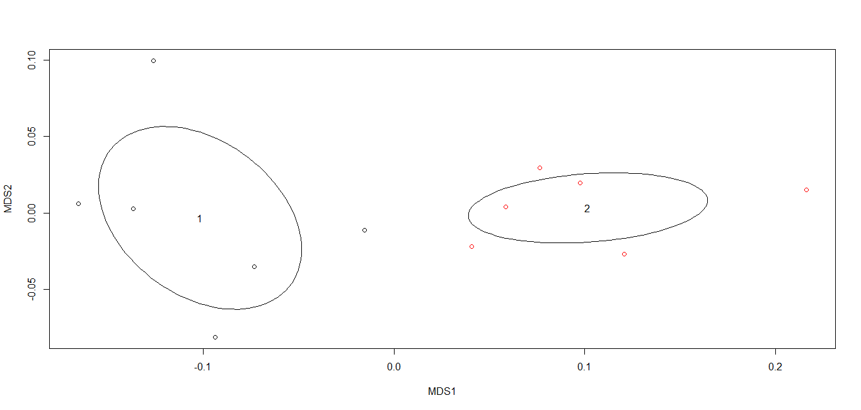
Figure 5. Comparison of the metabolic profiles in the microbial communities of the coral mucus in ambient water from the first Biolog Ecoplate inoculation (1) to the inoculation after three weeks (2).

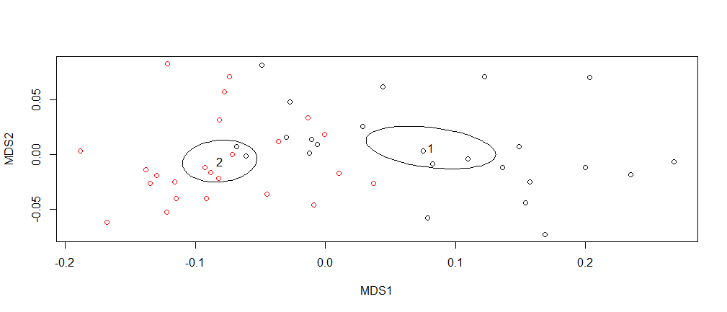
Figure 6. Comparison of the metabolic profiles in the microbial communities of the coral mucus in low pH water from the first Biolog Ecoplate inoculation (1) to the inoculation after three weeks (2).

Additionally, the metabolic profiles of the microbial communities of the coral taken after exposure to low pH for three weeks differed significantly from the metabolic profiles of the microbial communities of the coral taken after three weeks in ambient water for three weeks (ANOSIM p=0.014).

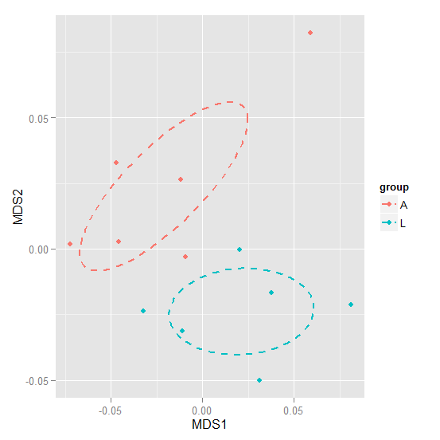
Figure 7. Comparison of the metabolic profiles of the microbial communities in the coral mucus of the coral in ambient water (A) and low pH water (L).

Discussion
The impact of ocean acidification on staghorn coral’s calcification rates, physiology, and microbial metabolic activity was measured. However, no genotypes of staghorn coral were found as particularly resilient.
The calcification rates of the coral were significantly higher in ambient water than in low pH water, similar to C. I Enochs et al (2014). However, the differences between the genotypes analyzed were not significant enough to determine which ones were more resilient. In low pH water, the least resilient genotype appeared to be genotype 9. Based on its negative change in buoyancy weight, its skeleton presumably dissolved when exposed to a pH of 7.7. Conversely, genotype 20 appeared to be the most resilient genotype because it had the greatest increase in buoyancy weight after exposure to low pH water. However the small number of replicates analyzed resulted in error bars that did not make either genotype’s change in buoyancy weight significantly different from the change of the other genotypes. Perhaps future replication of the study with a larger sample size of each genotype could lead to distinct winners and losers.
The physiology of the corals in both treatments gave mixed indications of stress. The lower photosynthetic rates of the coral in low pH water indicated that those coral fragments were experiencing more stress than the coral in ambient water. This lower photosynthetic rate of coral under acidic stress corresponds to the lowered photosynthetic rates seen in the round starlet coral under salinity stress in a study done by Nyawira et al (1987). Though differences was seen in photosynthetic rates between treatments and genotypes, none of these differences were statistically significant, and therefore, particularly resilient genotypes could not be identified.
Meanwhile, the respiration rates of the coral in ambient water were significantly greater than the respiration rates of coral in the low pH water, signifying that the coral in ambient water were experiencing higher levels of stress. This stress in ambient water may have been caused by the possible presence of a disease that claimed the lives many replicates. A lowered pH has been found to inhibit the spread of some coral diseases (Yakob and Mumby 2010). Thus, the acidity in the water of the low pH tanks in this experiment may have inhibited the disease that the ambient coral dealt with from impacting the coral in the low pH tanks. While a significant difference was seen in respiration rates between the treatments, no significant difference was seen between the genotypes, preventing assumptions to be made on which genotypes are more resilient to ocean acidification.
A shift in the metabolic profile of the coral microbial communities in both treatments was expected due the bottle effect on microbes. The bottle effect refers to non-specific changes in a microbial community that are caused by confinement (Hammes 2010). In this case, the tanks that confined the coral fragments resulted in the shift in the metabolic profile of both treatments. However, the metabolic profile of the microbial communities in the ambient pH tanks did not shift the same as those in low pH tanks. This divergence in microbial metabolic profiles of coral exposed to low pH water versus ambient pH is consistent with previous studies that have shown such shifts in the microbial communities in other coral species (Witt et al. 2011). However, the lack of significant differences between the metabolic profiles of the different genotypes restrict the ability to make a correlation between metabolic profiles and resilience to change in pH.

Conclusion

The health of A. cervicornis is directly threatened by ocean acidification, as demonstrated by the decreased calcification rates in this study as well as other studies on staghorn coral (Enochs et al 2014). Developing out-planting strategies for this coral based on identifying resilient genotypes would help aid the recovery of A. cervicornis. In this study, variation in resilience was observed between the six genotypes studied; however the differences in resilience were not significant enough to determine clearly stronger genotypes. Future replication of this experiment with a larger sample size for each genotype could lead to identification of resilient genotypes of staghorn coral.
The recovery of staghorn coral is critical to the vitality of many coral reef ecosystems (Burke and Maidens 2004). In addition to ocean acidification, other environmental factors are jeopardizing the future of staghorn coral, such as climate change (Caprenter 2008). Further research and restorative action could rescue this endangered species.

The health of reef-building coral species, such as A. cervicornis, staghorn coral, is critical to the health of many tropical marine communities. Staghorn coral is one of the fastest growing coral species having the potential to rapidly rebuild after disturbance (Hughes and Connell 1999). As seen in this study, as with other studies, increasing carbon emissions acidifying the ocean threatens the welfare of A. cervicornis is threatened (Enoch et al 2014).

Literature Cited

Acropora Biological Review Team. 2005. Atlantic Acropora status review document. Report to
National Marine Fisheries Service, Southeast Regional Office, March 3, 2005. 152 p.
Baums IB, Johnson ME, Devlin-Durante MK, Miller MW (2010) Host population genetic
structure and zooxanthellae diversity of two reef-building coral species along the Florida
Reef Tract and wider Caribbean. Coral Reefs 29:835 – 842
Burke, L. and J. Maidens (2004) Reefs at Risk in the Caribbean: Technical Report. World
Resource Institute. 1.1: 9-10
Carpenter, KE., Abrar, M., Aeby, G., Aronson, RB., Banks, S., et al. (2008). One-third of reef-
building corals face elevated extinction risk from climate change and local impacts. Science, 321 (5888), 560-563.
Comeau, S., Carpenter, R., & Edmunds, P. (2013). Coral reef calcifiers buffer their response to
ocean acidification using both bicarbonate and carbonate. Proc. R. Soc. B, 280(1753), 1-8.
Enochs et al. (2014) Effects of light and elevated pCO₂ on the growth and photochemical
efficiency of Acropora cervicronis. Coral Reefs, 33.2: 477-485

Gardner et al. (2003) Long-term region-wide declines in Caribbean corals. American

Association of the Advancement of Science 301: 958-960
Hammes et al. (2010) Critical Evaluation of the Volumetric “Bottle Effect” on Microbial Batch
Growth. Applied Environmental Microbiology, 76.4:1278-1281.
Hughes, T. P. and J. H. Connell (1999) Multiple stressors on coral reefs: A long-term
perspective. American Society of Limnology and Oceanography, 44: 932-940
Knowlton, Nancy (2001) The future of coral reefs. Proceedings of the National Academy of
Sciences of the United States. 98.10: 5419-5425
Langdon C, et al. Effect of calcium carbonate saturation state on the calcification rate of an
experimental coral reef. Global Biochem Cy. 2000;14:639–654.
Levinton S Jeffrey, Marine Biology: Function, Biodiversity, Ecology. Oxford University Press
2008;3rd Edition.
Muthiga, N. and A. M. Szmant (1987) The effects of salinity stress on the rates of aerobic
respiration and photosynthesis in the hermatypic coral Siderastrea sidereal. The Biological Bulletin, 173.3: 539-551.
Vollmer, S., Kline, D., & Bruno, J. (2008). Natural Disease Resistance In Threatened Staghorn
Corals. PLoS ONE, 3(11), 1-5
Witt et al. (2011) Effects of ocean acidification on microbial community composition oxygen
fluxes through, biofilms from the Great Barrier Reef. Environmental Microbiology, 13.11:2976-2989
Yakob, L. and P. J. Mumby (2010) Climate change induces demopgraphic resistance to disease
in novel coral assemblages. Proceedings of the National Academy of Sciences of the United States, 108.5: 1967-1969.

